Computer Shop System

Use-Case Specification: Create staff profile

Version 1.0

Revision History

|  |  |  |  |
| --- | --- | --- | --- |
| **Date** | **Version** | **Description** | **Author** |
| 15/12/2019 | 1.0 | details | Hoang Trung Hieu |
|  |  |  |  |
|  |  |  |  |
|  |  |  |  |

Table of Contents

1. Use-Case Name 3

1.1 Brief Description 3

2. Flow of Events 3

2.1 Basic Flow 3

2.2 Alternative Flows 3

2.2.1 < First Alternative Flow > 3

2.2.2 < Second Alternative Flow > 3

3. Special Requirements 3

3.1 < First Special Requirement > 3

4. Preconditions 3

4.1 < Precondition One > 3

5. Postconditions 3

5.1 < Postcondition One > 3

6. Extension Points 3

6.1 <Name of Extension Point> 3

Use-Case Specification: Create staff profile

# Use-Case Name

## Brief Description

This use case defines the step of how manager create for employee’s profile. In profile, it contains personal information such as name, address, phone number, position and etc.

# Flow of Events

## Basic Flow

The first step is that computer shop manager selects creating profile button in the system. Then, system displays the profile that contains all fields related to employee. After that, manager enters some employee’s information and submits it. System will check or validate input. If this profile is not existeed before, this use case continue and system saves it in database. Finally, system displays a successful message to notice that manager creates completely.

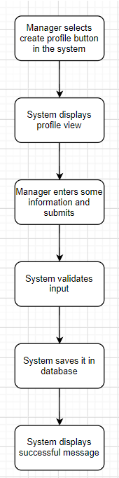

# Special Requirements

- No empty required fields such as name, phone number, email, date of brith, position.

- Have correct form of some fields:

+Email need ‘@’

+Phone number is integer

+Password and repeat password is the same

# Preconditions

Manager need to log in system and select profile management function.

# Postconditions

No postconditions.

# Extension Points

None.